ASSIGNMENT-5.1 AND 6
Task 1:
Employee Data:
CODE:
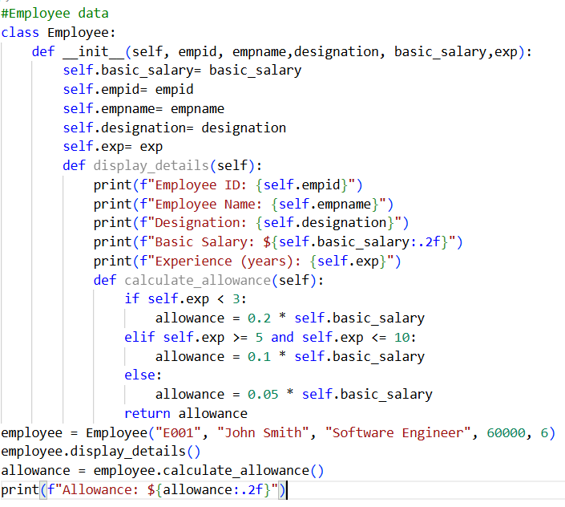
Task 2:
Electricity Bill Calculation:
CODE:
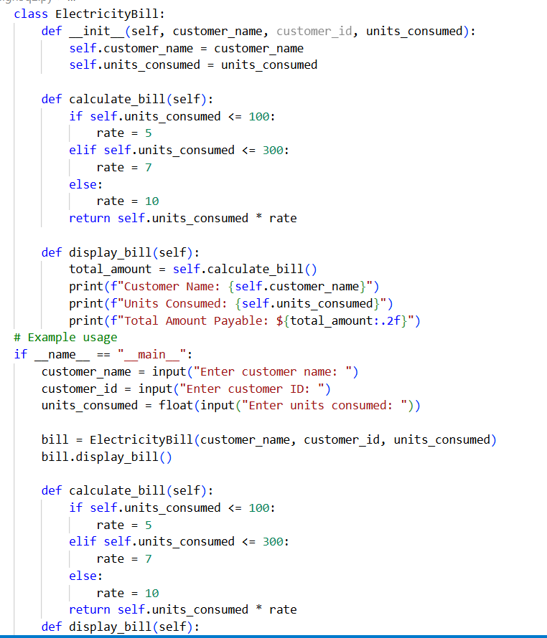
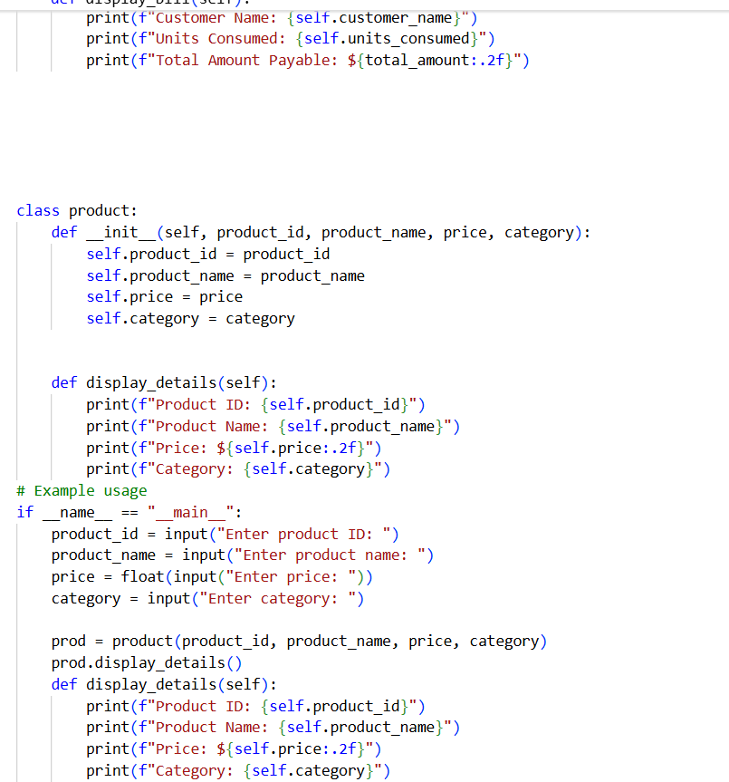
OUTPUT:
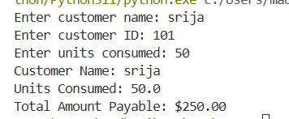
Task 3:
Product Discount Calculation:
CODE:
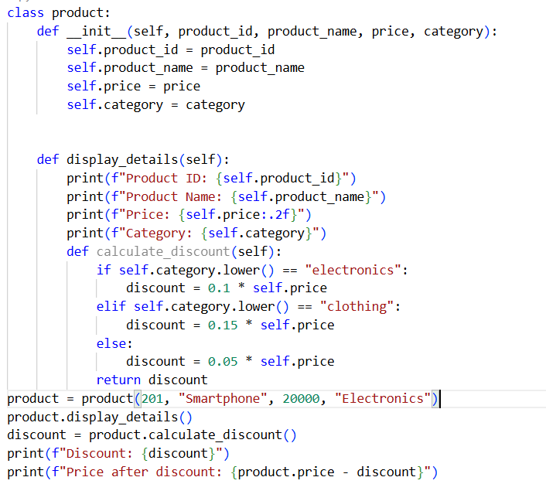
OUTPUT:
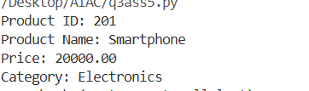

Task 4:
Book Late Fee Calculation:
CODE:
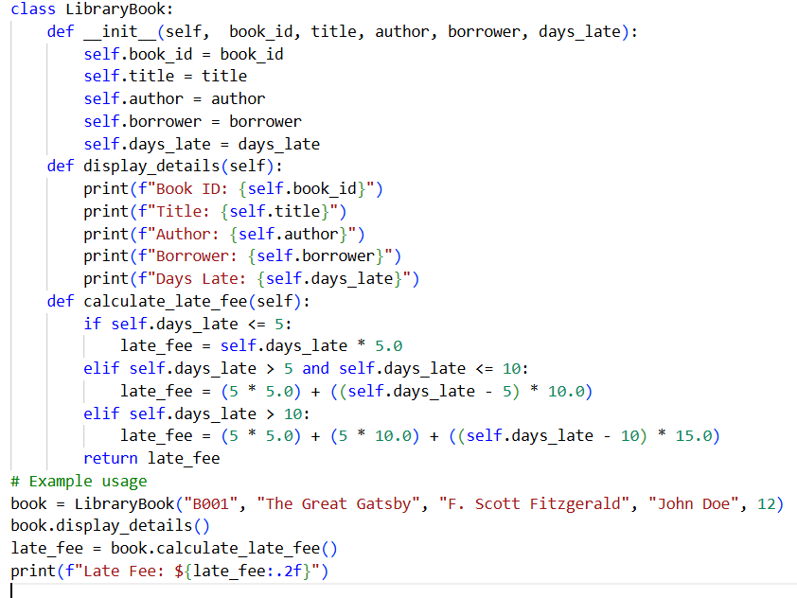
OUTPUT:
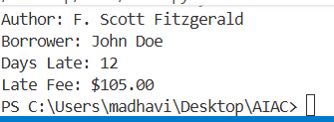
TASK5:
Student Performance Report:
Code:
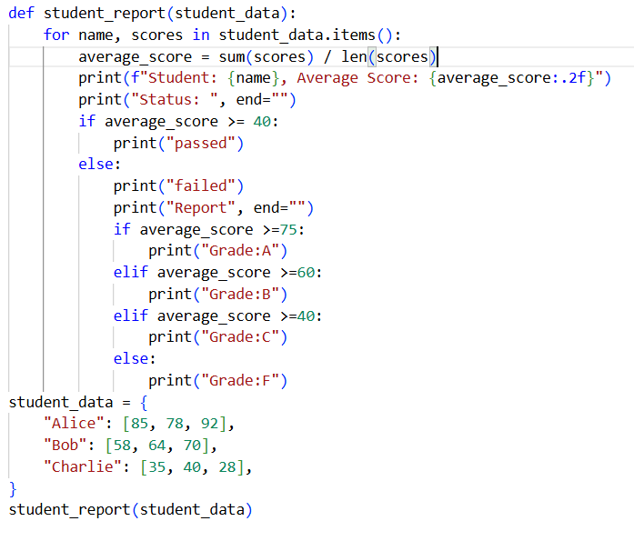

Output:
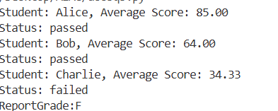

Task 6:
Taxi Fare Calculation:
CODE:
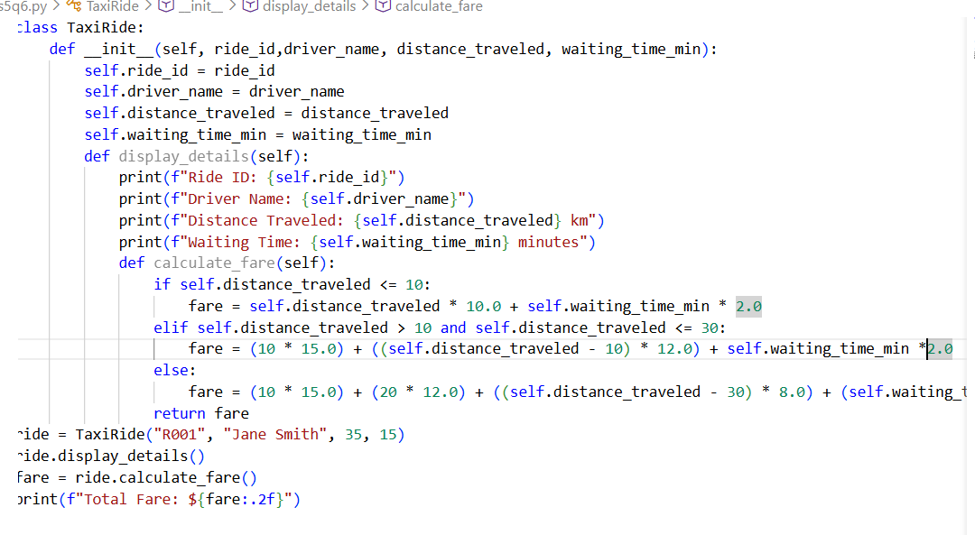
OUTPUT:
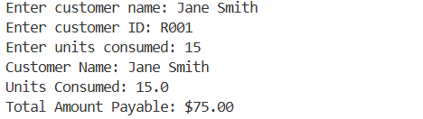
Task 7:
Statistics Subject Performance:
CODE:
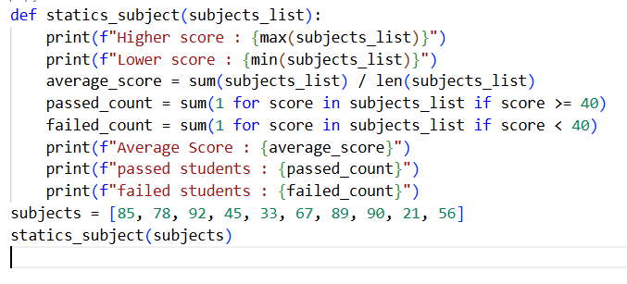
OUTPUT:
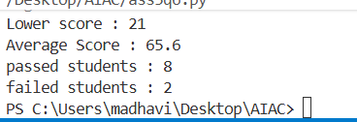

Task 8:
(Transparency in Algorithm Optimization)
CODE:
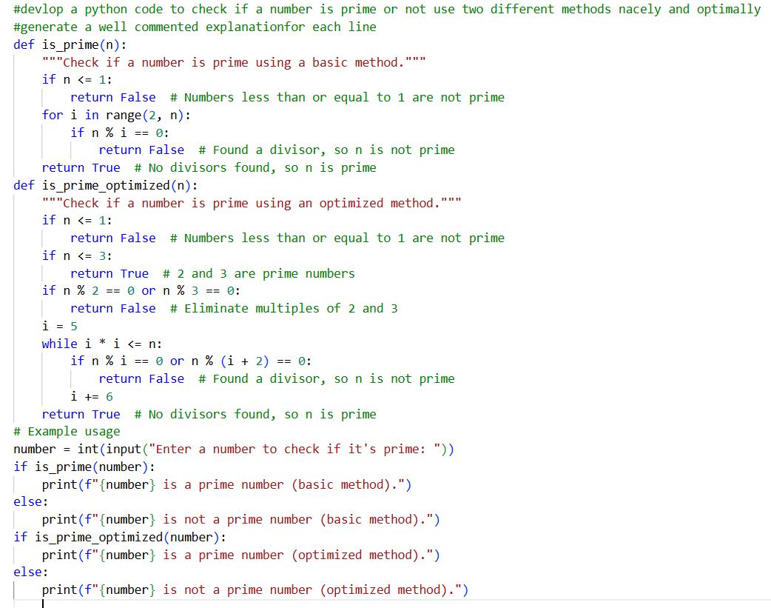
OUTPUT:
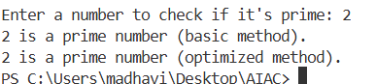
Task 9 :
(Transparency in Recursive Algorithms)
CODE:
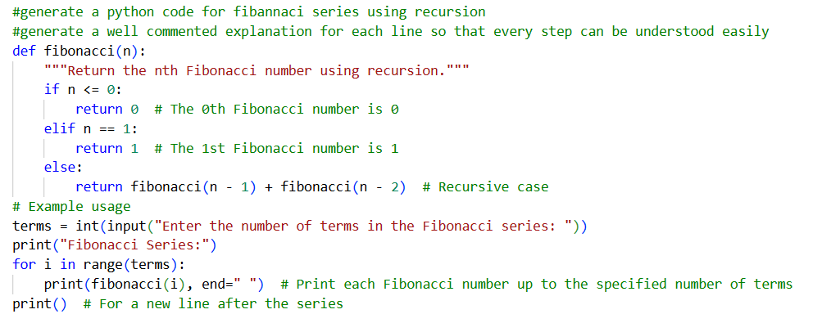
OUTPUT:
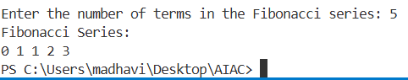
Task 10:
(Transparency in Error Handling)
CODE:
